Tool & Technique Laboratory (T&T Lab.)

[CS-3096]
Individual Work
Lab. No:7 , Date:28-02-2023 , Day:Tuesday
Topic:
Roll Number: | 20051939 | Branch/Section: | CSE-17
Name in Capital: | Shashikant shah

(Instruction: Rename this file as r-LAB-x where r is your roll number & x is your lab. number & Suppose your roll number is 1905123 & you want to submit lab-2 programs, then file name should be 1905123-LAB-2. Finally delete all texts inside parentheses, also parenthesis)

Program No: (1)

Program Title:
()# 1. Write a NumPy program to concatenate element-wise two arrays of string.

# Sample Output:
# Array1:
# ['Python' 'PHP' ]
# Array2:
# [' Java' ' C++']
# new array:
# ['Python Java' 'PHP C++']

Input/Output Screenshots:
RUN-1:
(Paste here the screenshots of first run)

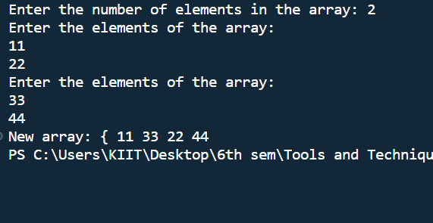

RUN-2
(Paste here the screenshots of second run )
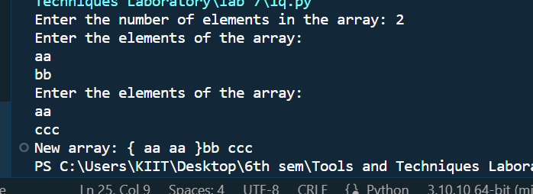

Source code
(Paste here the source code)

n = int(input("Enter the number of elements in the array: "))
print("Enter the elements of the array: ")
arr1 = np.array([input() for i in range(n)])
print("Enter the elements of the array: " )
arr2 = np.array([input() for i in range(n)])
print("New array: {", end = " ")
# add space between the elements of the array
new_arr = []
for i in range(n):
new_arr.append(arr1[i] + " " + arr2[i])
print(" ".join(new_arr), end = " ")
#

Conclusion/Observation

successfully compiled the code

Program No: (2)

Program Title:
(# 2. Write a NumPy program to split the element of a given array with spaces.

# Sample Output:
# Original Array:
# ['Python PHP Java C++']
# Split the element of the said array with spaces:
# [list(['Python', 'PHP', 'Java', 'C++'])]l)

Input/Output Screenshots:
RUN-1:
(Paste here the screenshots of first run)

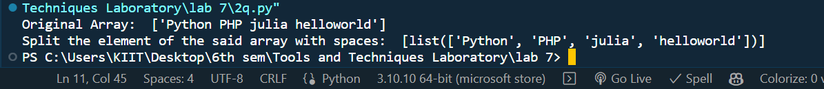

Source code
(Paste here the source code)

import numpy as np

arr = np.array(['Python PHP julia helloworld'])
print("Original Array: ", arr)
print("Split the element of the said array with spaces: ", np.char.split(arr))

Conclusion/Observation

successfully compiled the code

Program No: (3)

Program Title:
(# 3. Write a NumPy program to count the lowest index of "P" in a given array, element-wise.
# Sample Output:
# Original Array:
# ['Python' 'PHP' 'JS' 'EXAMPLES' 'HTML']
# count the lowest index of 'P':
# [ 0 0 -1 4 -1]
)

Input/Output Screenshots:
RUN-1:
(Paste here the screenshots of first run)

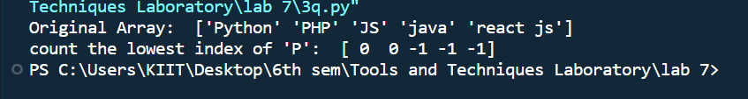

Source code
(Paste here the source code)
import numpy as np
arr = np.array(['Python', 'PHP', 'JS', 'java', 'react js'])
print("Original Array: ", arr)
print("count the lowest index of 'P': ", np.char.find(arr, 'P'))

Conclusion/Observation

successfully compiled the code

Program No: (4)

Program Title:
(# 4. Write a NumPy program to count a given word in each row of a given array of string values. Sample output:
# Original array of string values:
# [['Python' 'NumPy' 'Exercises']
# ['Python' 'Pandas' 'Exercises']
# ['Python' 'Machine learning' 'Python']]
# Count 'Python' row wise in the above array of string values:
# [[1 0 0]
# [1 0 0]
# [1 0 1]])

Input/Output Screenshots:
RUN-1:
(Paste here the screenshots of first run)

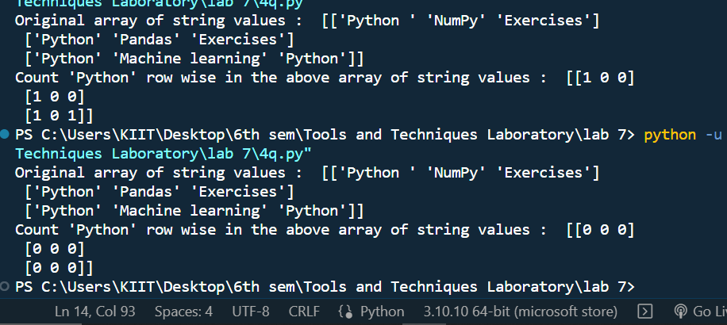

Source code
(Paste here the source code)

import numpy as np
arr = np.array([['Python ', 'NumPy', 'Exercises'], ['Python', 'Pandas', 'Exercises'], ['Python', 'Machine learning', 'Python']])
print("Original array of string values : ", arr)
print("Count 'Python' row wise in the above array of string values : ", np.char.count(arr, 'Python'))

Conclusion/Observation

successfully compiled the code

Program No: (5)

Program Title:
(# 5. WAP to print max from axis 0 and min from axis 1 from the following 2-D array.
# Sample output:
# Printing Original array
# [[34 43 73]
# [82 22 12]
# [53 94 66]]

# Printing amin Of Axis 1
# [34 12 53]

# Printing amax Of Axis 0
# [82 94 73])

Input/Output Screenshots:
RUN-1:
(Paste here the screenshots of first run)

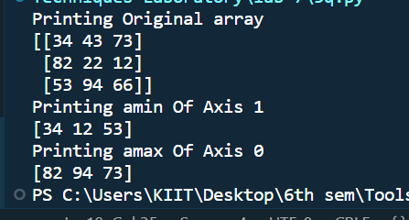

RUN-2
(Paste here the screenshots of second run )

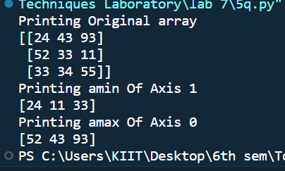

Source code
(Paste here the source code)

import numpy as np
arr = np.array([[24, 43, 93], [52, 33, 11], [33, 34, 55]])
print("Printing Original array")
print(arr)
print("Printing amin Of Axis 1")
print(np.amin(arr, axis = 1)) # axis = 1 means row wise operation and amin use to find minimum value
print("Printing amax Of Axis 0") # axis = 0 means column wise operation and amax use to find maximum value
print(np.amax(arr, axis = 0))

Conclusion/Observation

successfully compiled the code

Program No: (6)

Program Title:
(# 6. WAP to delete the second column from a given array and insert the following new column in its
# place.

# Sample output:
# Printing Original array
# [[34 43 73]
# [82 22 12]
# [53 94 66]]

# Array after deleting column 2 on axis 1
# [[34 73]
# [82 12]
# [53 66]]

# Array after inserting column 2 on axis 1
# [[34 10 73]
# [82 10 12]
# [53 10 66]])

Input/Output Screenshots:
RUN-1:
(Paste here the screenshots of first run)
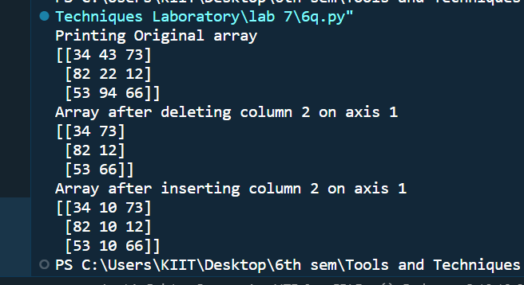

RUN-2
(Paste here the screenshots of second run )

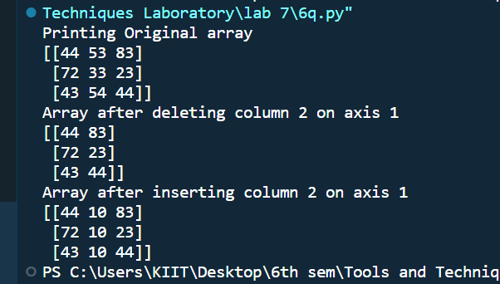

Source code
(Paste here the source code)

import numpy as np
arr = np.array([[44, 53, 83], [72, 33, 23], [43, 54, 44]])
print("Printing Original array")
print(arr)
print("Array after deleting column 2 on axis 1")
arr = np.delete(arr, 1, axis = 1)
print(arr)
print("Array after inserting column 2 on axis 1")
arr = np.insert(arr, 1, 10, axis = 1)
print(arr)

Conclusion/Observation

successfully compiled the code

Program No: (7)

Program Title:
(Write here your program title in detail)
# 7. WAP to Convert a 1-D array into a 2-D array with 3 rows
# Sample output:
# Start with: exercise_2 = np.array([0, 1, 2, 3, 4, 5, 6, 7, 8])
# Desired output:
# [[ 0, 1, 2]
# [3, 4, 5]
# [6, 7, 8]]

Input/Output Screenshots:
RUN-1:
(Paste here the screenshots of first run)
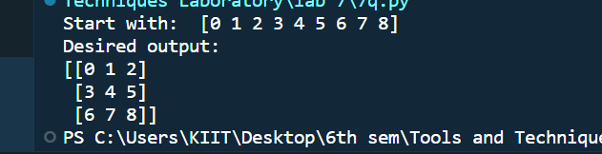

Source code
(Paste here the source code)

import numpy as np
arr = np.array([0, 1, 2, 3, 4, 5, 6, 7, 8])
print("Start with: ", arr)
print("Desired output: ")
print(arr.reshape(3, 3))

Conclusion/Observation
successfully compiled the code

Program No: (8)

Program Title:
(# 8. WAP to generate a 1-D array of 10 random integers. Each integer should be a number between 30
# and 40 (inclusive)
# Sample output:

# [36, 30, 36, 38, 31, 35, 36, 30, 32, 34])

Input/Output Screenshots:
RUN-1:
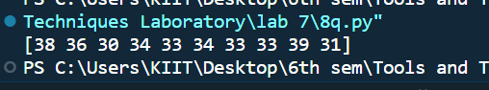

Source code
(Paste here the source code)
import numpy as np
arr = np.random.randint(30, 41, 10)
print(arr)

Conclusion/Observation

successfully compiled the code

Program No: (9)

Program Title:
# 9. WAP to Replace all odd numbers in the given array with -1
# Sample output:
# Start with: exercise_1 = np.array([0, 1, 2, 3, 4, 5, 6, 7, 8, 9])
# Desired output:
# [ 0, -1, 2, -1, 4, -1, 6, -1, 8, -1]

Input/Output Screenshots:
RUN-1:
(Paste here the screenshots of first run)

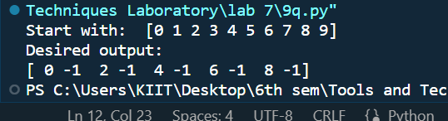

Source code
(Paste here the source code)

import numpy as np
arr = np.array([0, 1, 2, 3, 4, 5, 6, 7, 8, 9])
print("Start with: ", arr)
print("Desired output: ")
arr[arr % 2 == 1] = -1
print(arr)

Conclusion/Observation

successfully compiled the code

Program No: (10)

Program Title:
# 10. WAP to create a 5X2 integer array from a range between 100 to 200 such that the difference
# between each element is 10
# Sample output:
# Creating 5X2 array using numpy.arange
# [[100 110]
# [120 130]
# [140 150]
# [160 170]
# [180 190]]

Input/Output Screenshots:
RUN-1:
(Paste here the screenshots of first run)

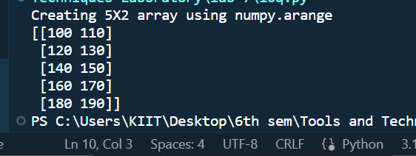

Source code
(Paste here the source code)
import numpy as np
arr = np.arange(100, 200, 10).reshape(5, 2)
print("Creating 5X2 array using numpy.arange")
print(arr)

Conclusion/Observation

successfully compiled the code

